Using a PIR to Detect Movement

HC-SR501 PIR SENSOR

This example shows how to use an HC-SR501 PIR sensor (movement sensor). You will connect it up to pin 8 of your Arduino board and the input will be used to trigger the onboard LED.

Hardware Required

* Arduino Board
* onboard LED on pin 13
* HC-SR501 PIR sensor

Circuit

Connect power and ground as illustrated. Then connect the sensor pin to digital pin 8 on your Arduino.

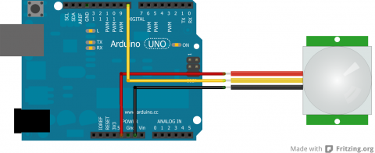

Code

// Uses a PIR sensor to detect movement and turn on a LED

int ledPin = 13; // choose the pin for the LED  
int inputPin = 8; // choose the input pin (for PIR sensor)  
int pirState = LOW; // we start, assuming no motion detected  
int val = 0; // variable for reading the pin status

void setup() {  
  pinMode(ledPin, OUTPUT); // declare LED as output  
  pinMode(inputPin, INPUT); // declare sensor as input  
  Serial.begin(9600);  
}

void loop(){  
  val = digitalRead(inputPin); // read input value  
  if (val == HIGH) { // check if the input is HIGH  
    digitalWrite(ledPin, HIGH); // turn LED ON  
    delay(150);

    if (pirState == LOW) {  
      // we have just turned on  
      Serial.println("Motion detected!");  
      // We only want to print on the output change, not state  
      pirState = HIGH;  
    }  
  } else {  
    digitalWrite(ledPin, LOW); // turn LED OFF  
    delay(300);   
    if (pirState == HIGH){  
      // we have just turned off  
      Serial.println("Motion ended!");  
      // We only want to print on the output change, not state  
      pirState = LOW;  
    }  
  }  
}